Library Management System
**A Desktop Application using F# & WinForms
1. Project Overview
The F# Library Management System is a lightweight desktop application developed in F# on the .NET 8 platform using Windows Forms as the graphical user interface. The system manages a small library by allowing two distinct user roles:
- Regular User – can search, borrow, and return books.
- Administrator – can add, edit, delete, and search books.
All data is persisted in a JSON file (library.json) using System.Text.Json. The application follows clean separation of concerns: business logic is isolated in LibraryManager.fs while the UI is handled by separate forms.
2. Objectives
- Implement CRUD operations in a functional-first language (F#).
- Provide role-based access (User vs Admin).
- Ensure data integrity (prevent edit/delete of borrowed books).
- Demonstrate serialization/deserialization with JSON.
- Write comprehensive unit tests using xUnit.
3. Main Features
Common Features (both panels)
- Search books by title or author (case-insensitive)
- View all books with status (Available / Borrowed)
- Automatic save/load from library.json
User Panel
- Borrow a book by ID
- Return a book by ID
- Visual indication (red background for borrowed books)
Admin Panel
- Add new book
- Edit existing book (blocked if borrowed)
- Delete book (blocked if borrowed)
- Re-numbering of IDs after deletion
4. Technologies Used
- Language: F# 8.0 (.NET 8)
- UI Framework: Windows Forms (WinForms)
- Data Persistence: System.Text.Json
- Testing: xUnit
- IDE: Visual Studio

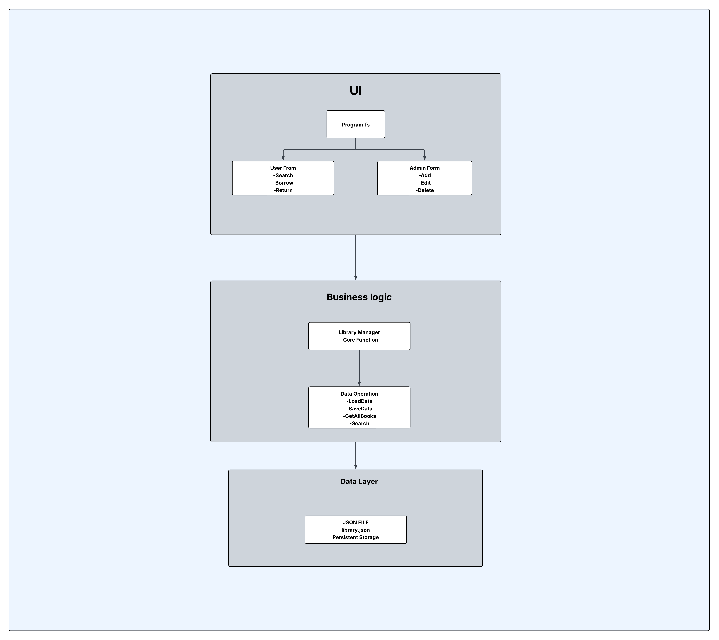
5. System Architecture

6. Block Diagram
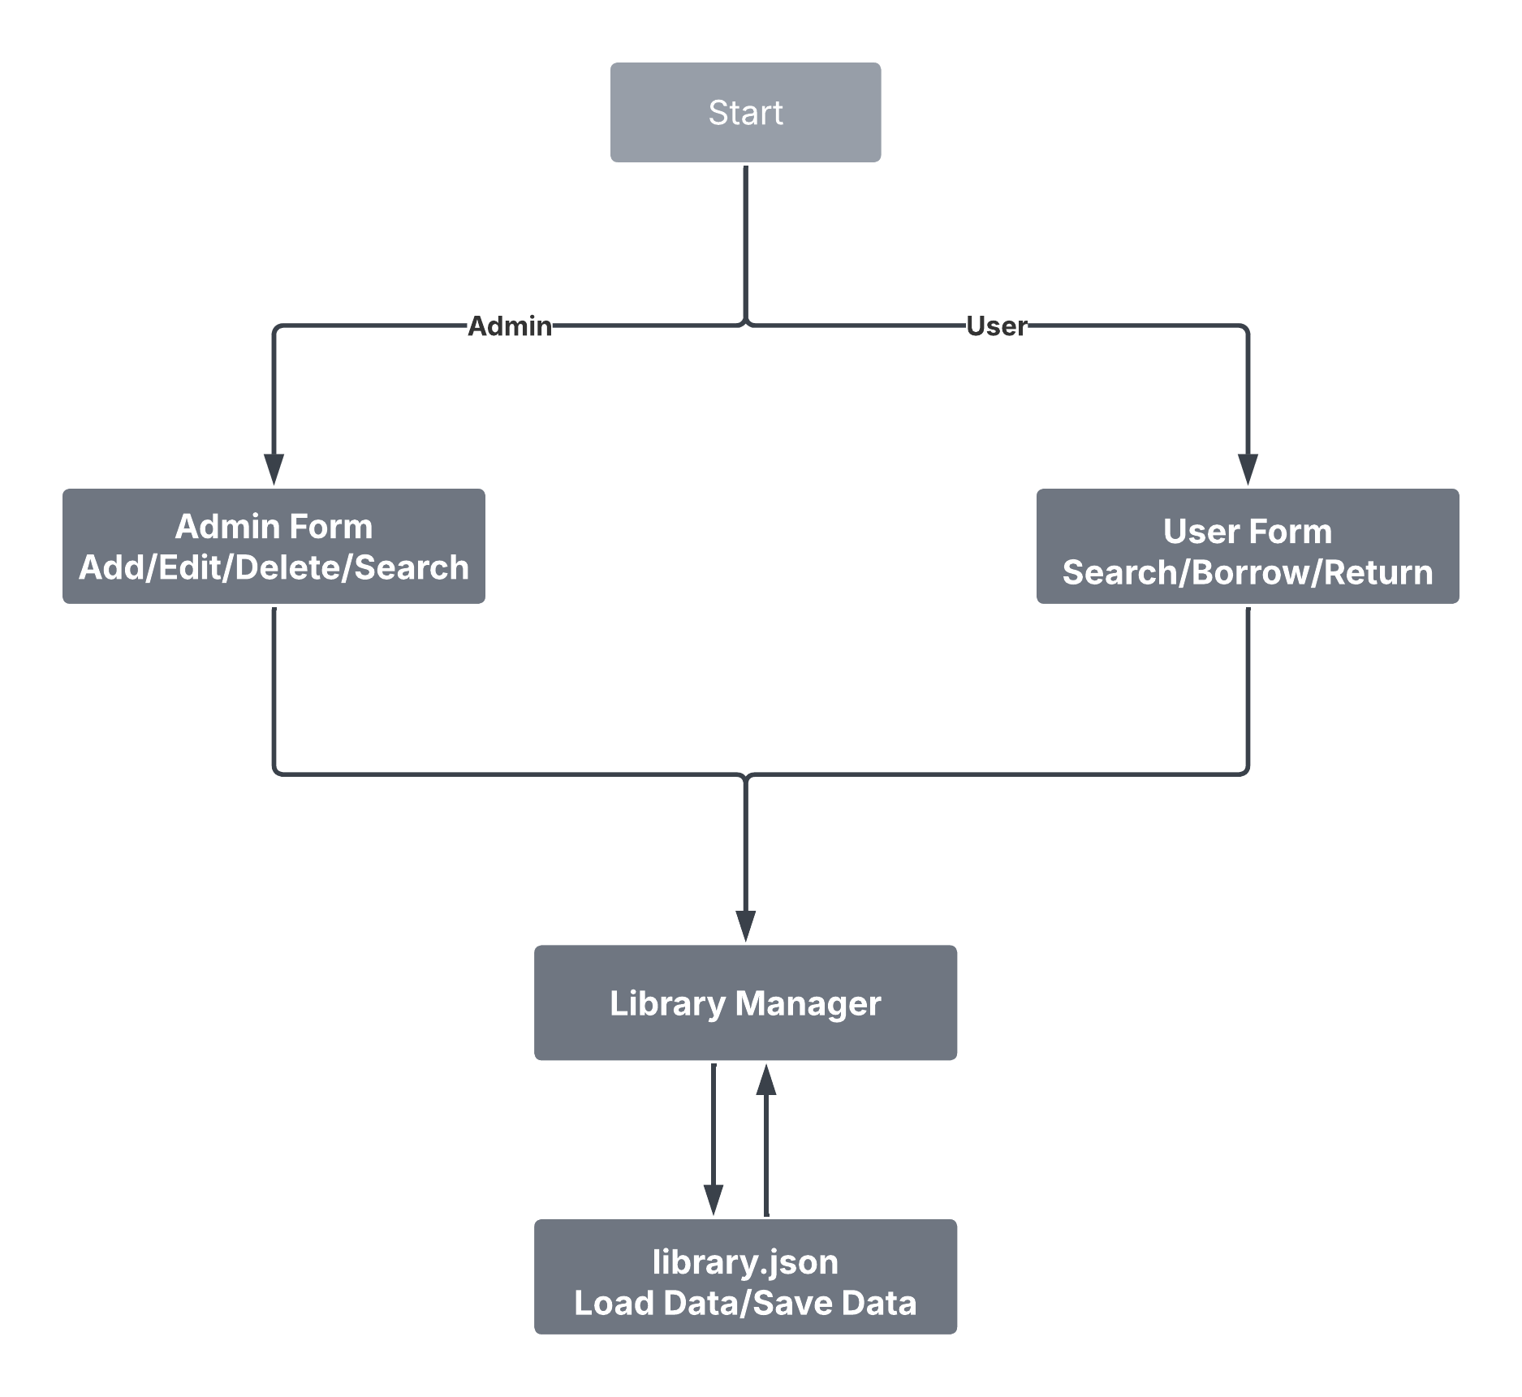

7. User Interface Description
- Welcome Form – Simple role selection screen.
- User Form – Clean layout with search bar, book list, and Borrow/Return buttons.
- Admin Form – Additional input fields and Add/Edit/Delete controls. All forms use the same color scheme and consistent font (Segoe UI

8. Testing Strategy
Framework: xUnit Number of Tests: 5 unit tests covering all core functions.

Test Name | Purpose | Expected Result
Add book increases count | Verify a new book is added correctly | Count = 1
Search works | Case-insensitive search returns correct book | 1 result
Borrow and Return works | Toggle availability correctly | Status changes
Edit book updates data | Edit fails when book is borrowed | Update blocked if borrowed
Delete book removes it and renumbers | Delete fails when borrowed, IDs renumbered | Correct count & IDs

All tests run on an isolated test_library.json file to ensure independence.
9. How to Run the Project
- Open the solution in Visual Studio 2022.
- Set LibraryManagementSystem (not the Tests project) as Startup Project.
- Press F5.
- Welcome screen appears → choose User or Admin.
- Data is automatically saved to bin\Debug\net8.0-windows\library.json.

10. Conclusion & Future Enhancements
The project successfully demonstrates the power of F# in building maintainable desktop applications with a clean functional core. Possible future improvements:
- Borrowing history and due dates

